|  |  |  |
| --- | --- | --- |
|  | **SRI KRISHNA COLLEGE OF TECHNOLOGY**  **An Autonomous Institution | Accredited by NAAC with 'A' Grade**  **Affiliated to Anna University | Approved by AICTE**  **KOVAIPUDUR, COIMBATORE 641042** |  |

**GYM TRAINER AND PROGRESS TRACKER**

**APPLICATIONA PROJECT REPORT**

***Submitted by***

**GIRISHKANTH D (RegisterNo:727822TUCS037**)

**XXX (RegisterNo:123**)

**XXX (RegisterNo:123**)

***in partial fulfilment for the award of the degree***

Of

#### BACHELOR OF TECHNOLOGY

**IN**

**Computer Science & Engineering**

**JULY - 2024**

**GYM TRAINER AND PROGRESS TRACKER**

**APPLICATIONA PROJECT REPORT**

**INTRODUCTION:**

In today's fast-paced world, maintaining a consistent fitness routine and tracking physical progress can be challenging. To address this, we present the Gym Trainer and Progress Tracker Application, a comprehensive web-based solution designed to assist users in managing workouts, tracking progress, and achieving fitness goals. This application serves as a virtual fitness companion, providing access to various workout programs, a progress dashboard, and personalized profiles.

Built using modern web technologies like React.js and Material-UI, the application focuses on user experience with features such as a home page overview, secure login and signup, a detailed workout section with instructional guides, and a robust progress tracking system. It empowers users by guiding them through exercises and tracking progress over time, helping them stay motivated and on track. The application also includes an admin dashboard for managing user roles and content, offering a holistic approach to fitness management.

**OBJECTIVE:**

The **Gym Trainer and Progress Tracker Application** aims to provide users with a comprehensive platform to manage their fitness routines and track their progress. The primary objective is to offer detailed workout programs, complete with visual aids and instructions, ensuring exercises are performed correctly and safely. Additionally, users can log workouts, monitor progress, and visualize achievements through intuitive dashboards. The platform features secure access and personalized profiles for tracking fitness metrics. An admin dashboard allows for user account and content management. Utilizing modern web technologies, the application ensures a seamless experience across various devices, supporting users in their fitness journey and helping them achieve their goals.

**USER FLOW CHART:**

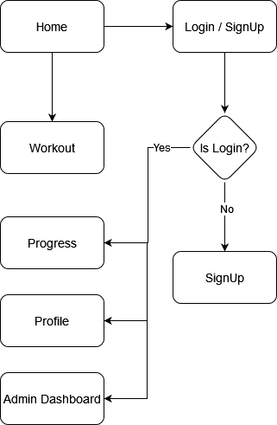

**USER MODULES:**



**Navigation Bar**

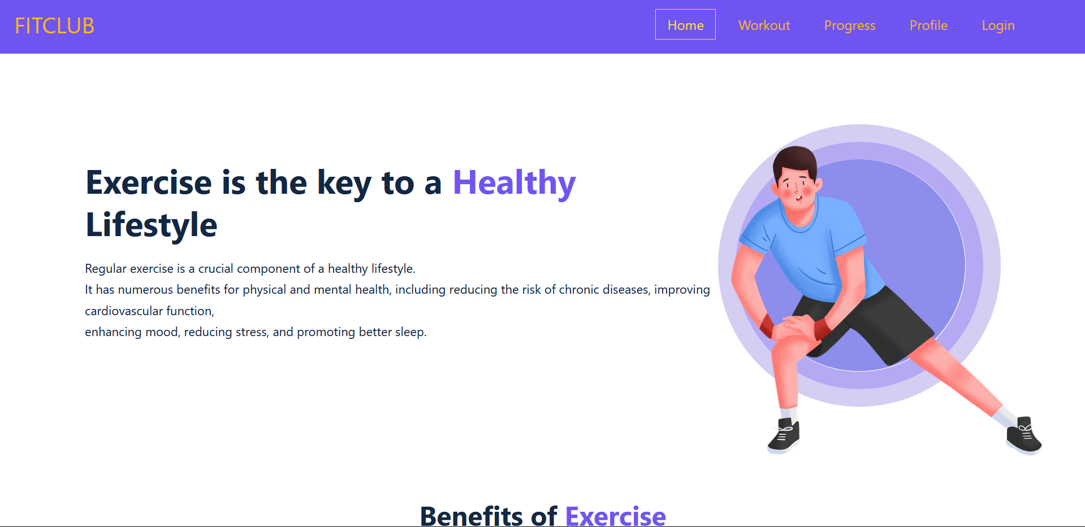 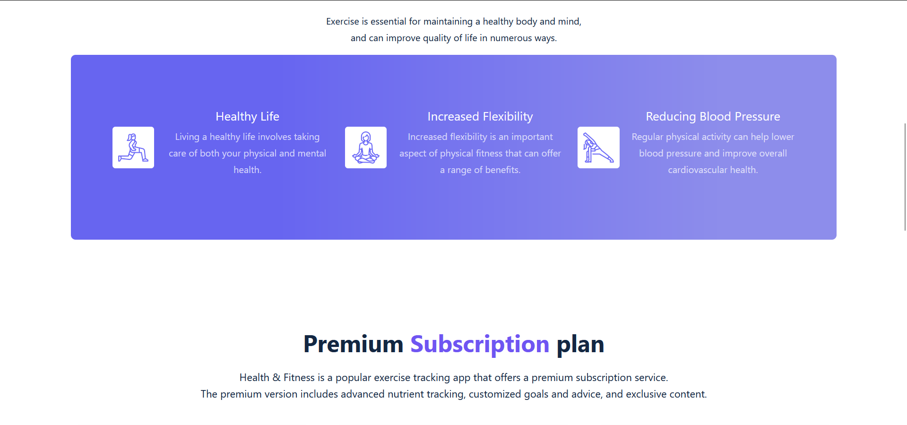

**Home Page**

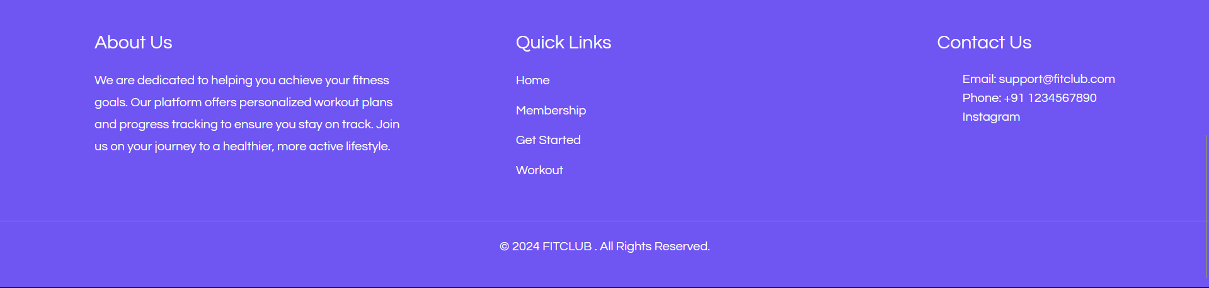

**Footer**

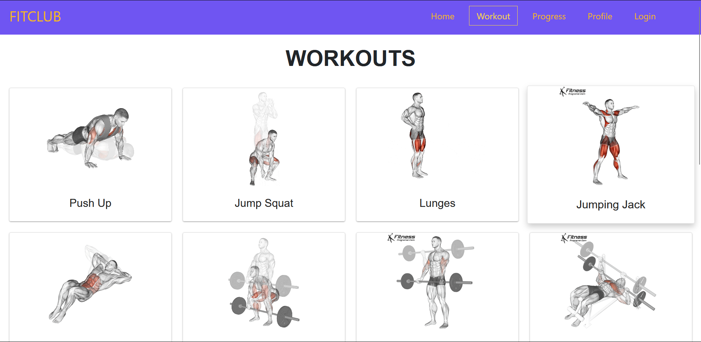  
 **Workout Page**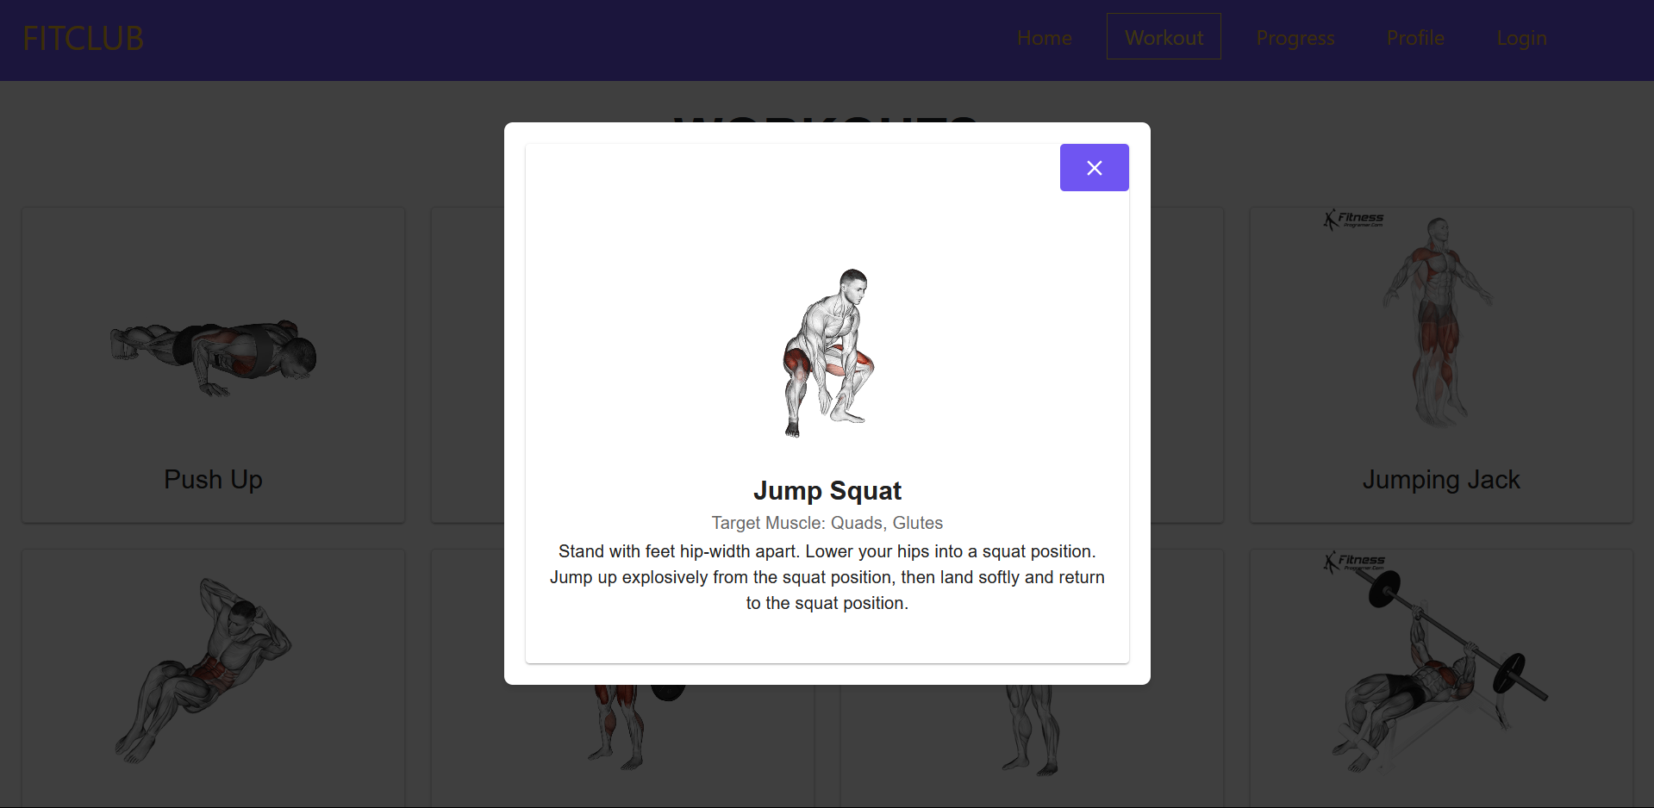

**WorkoutModal Component**

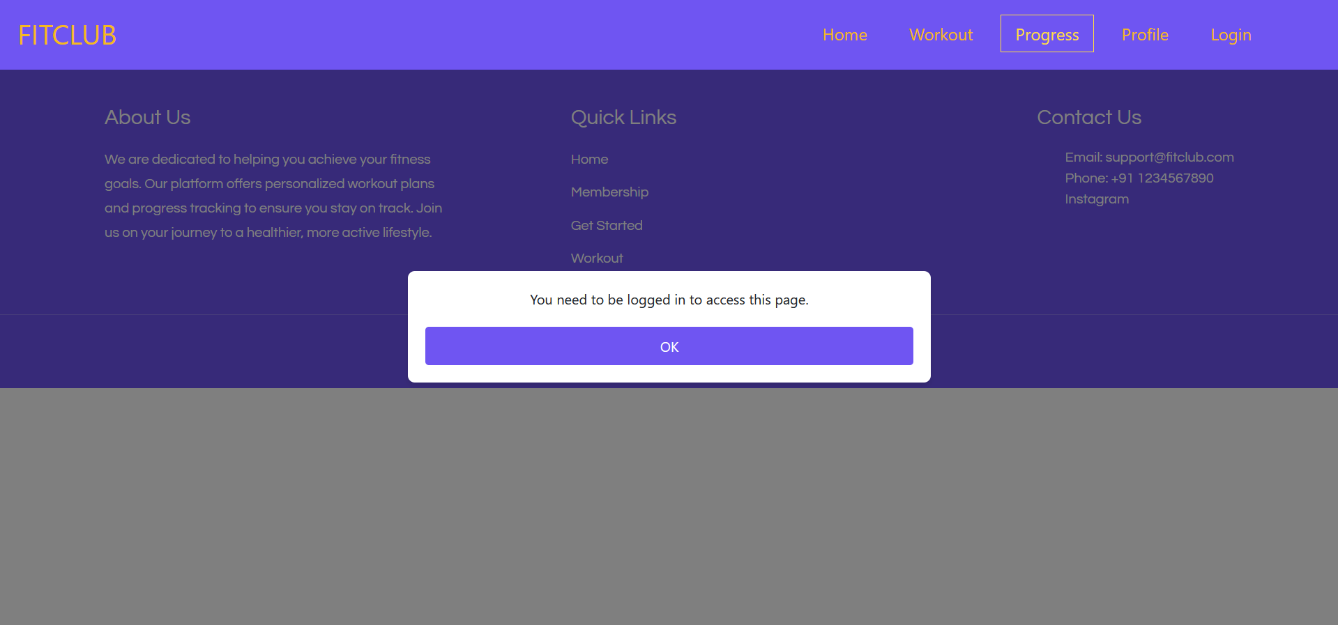

**PrivateModal Component**  
  
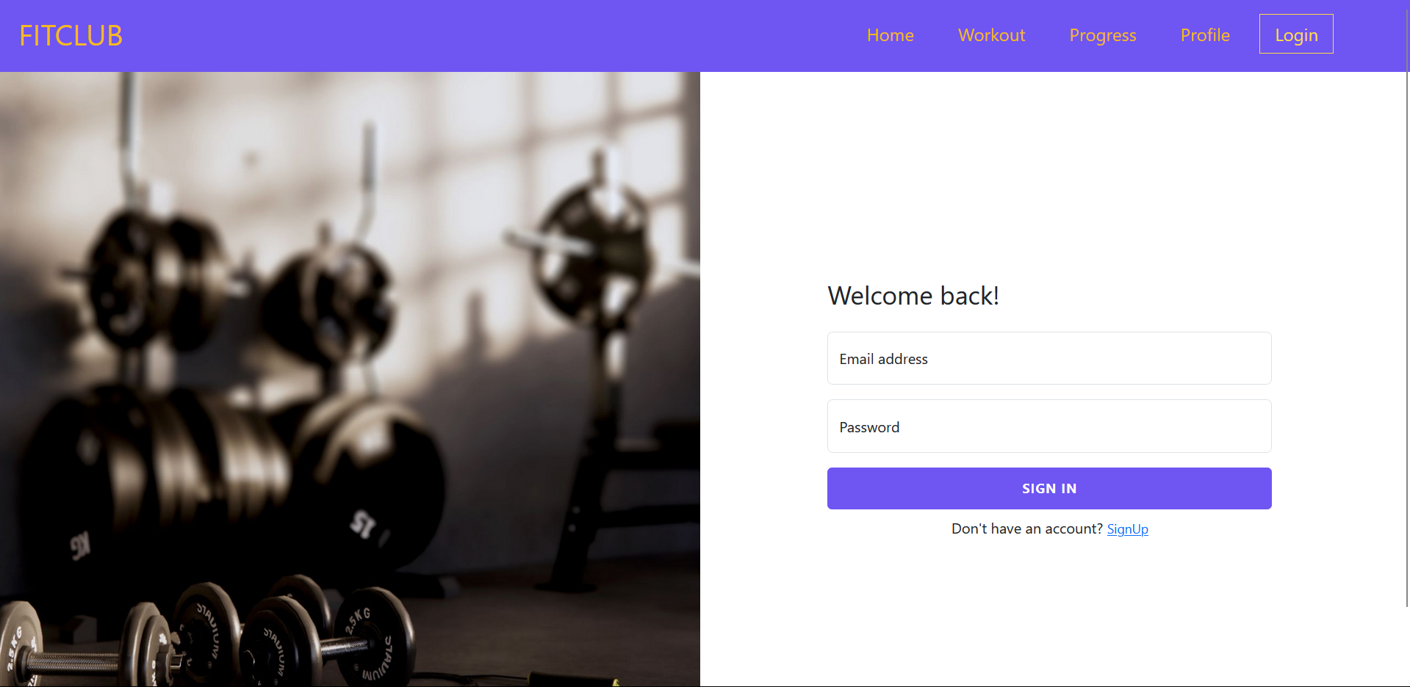

**Login Page**

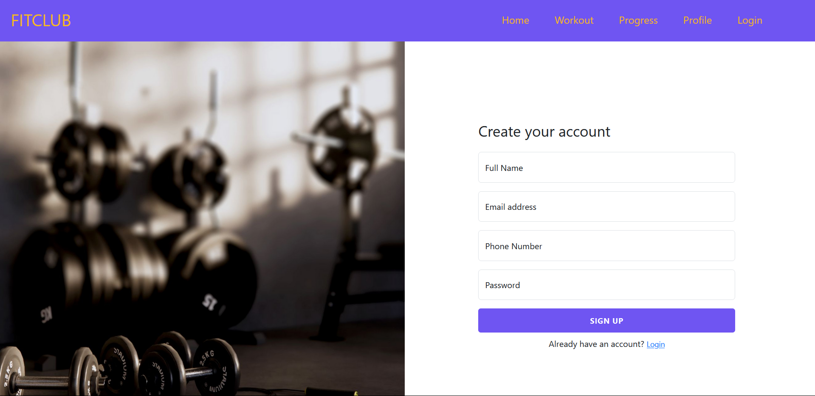

**Signup Page**

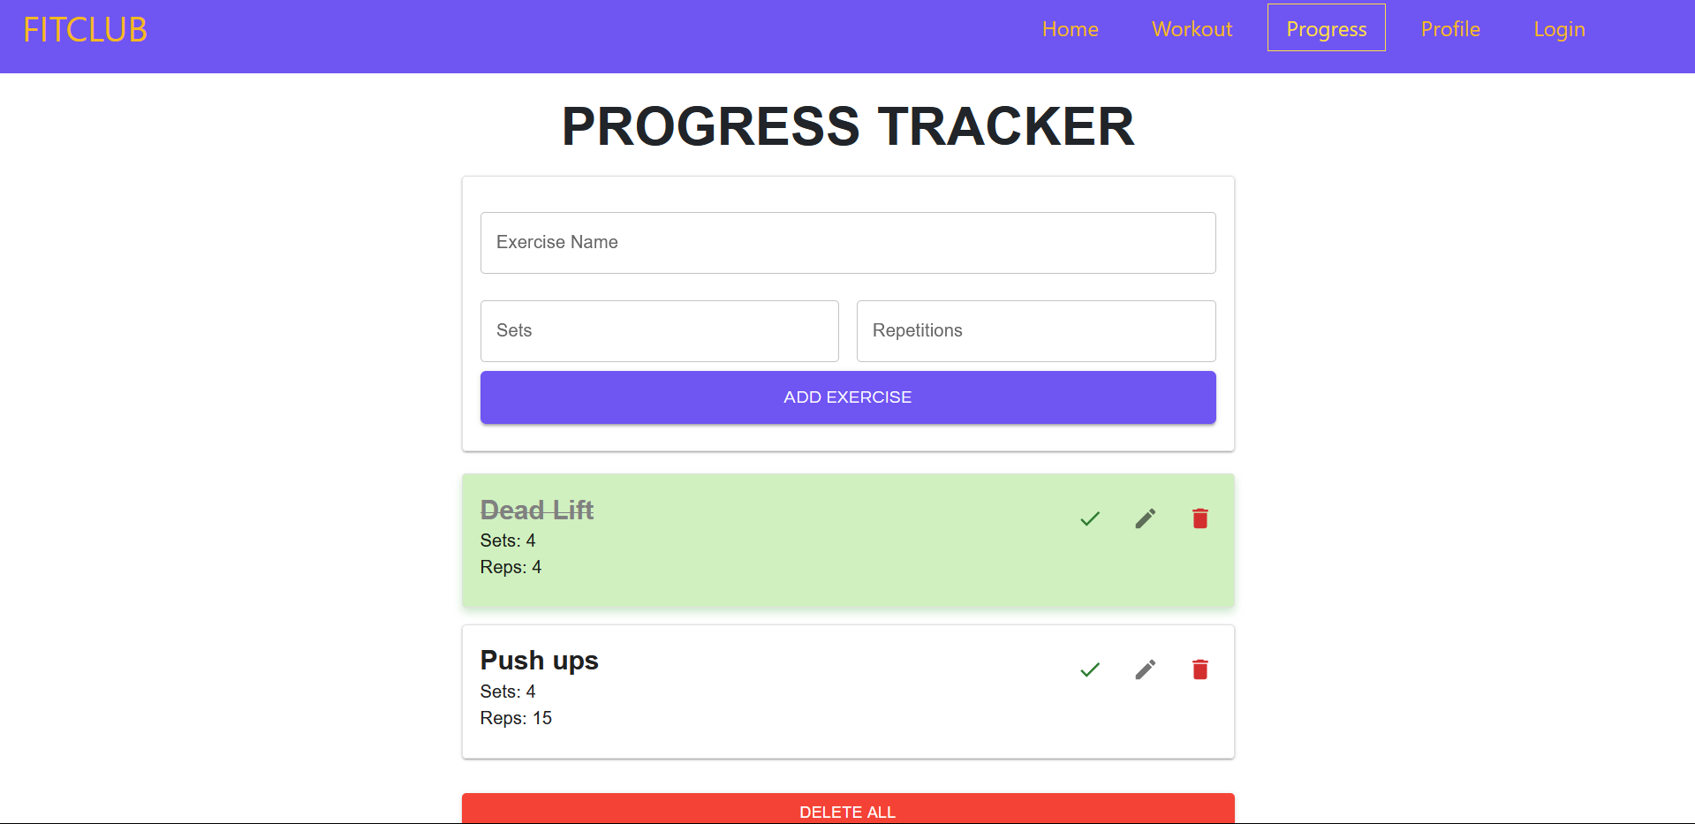

**Progress Page**

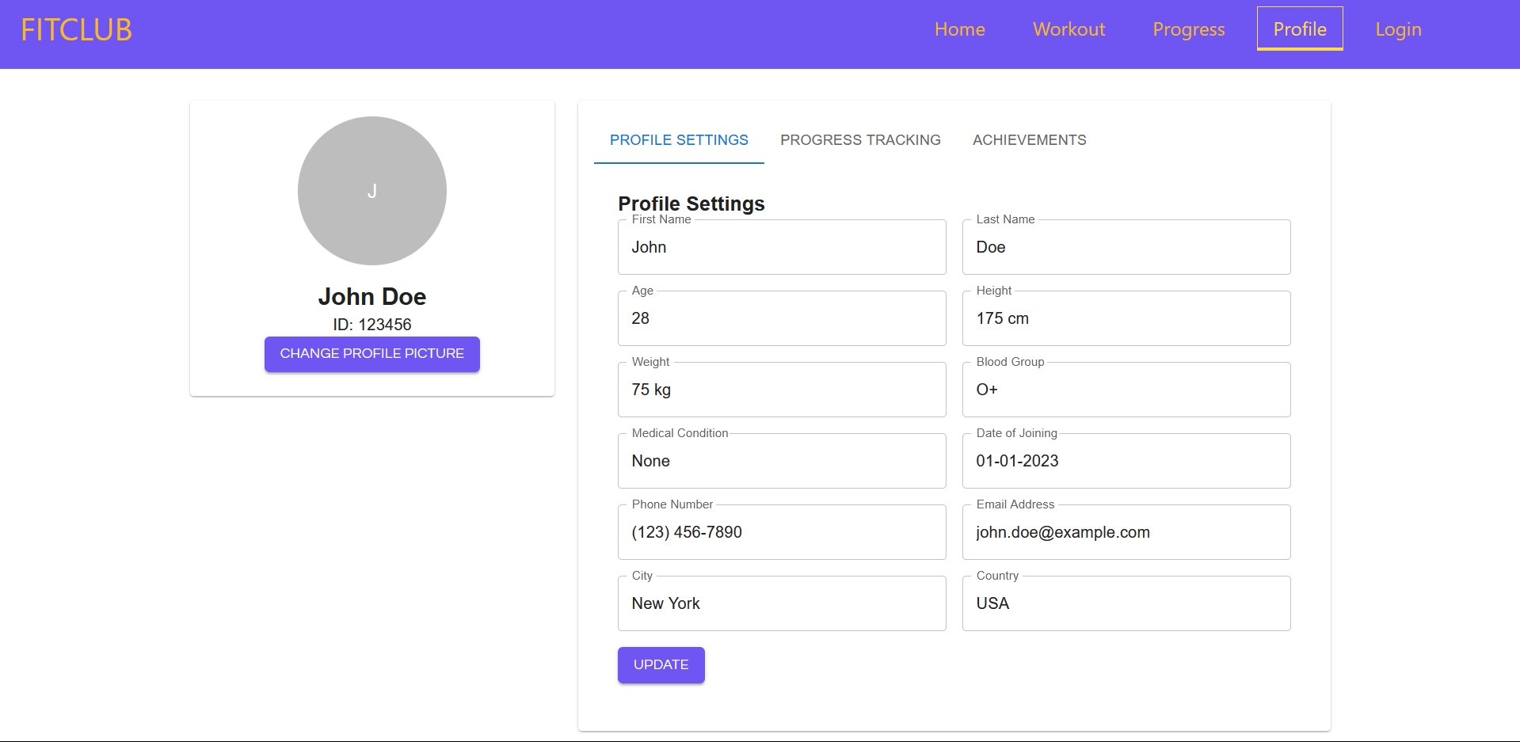

**Profile Page**

**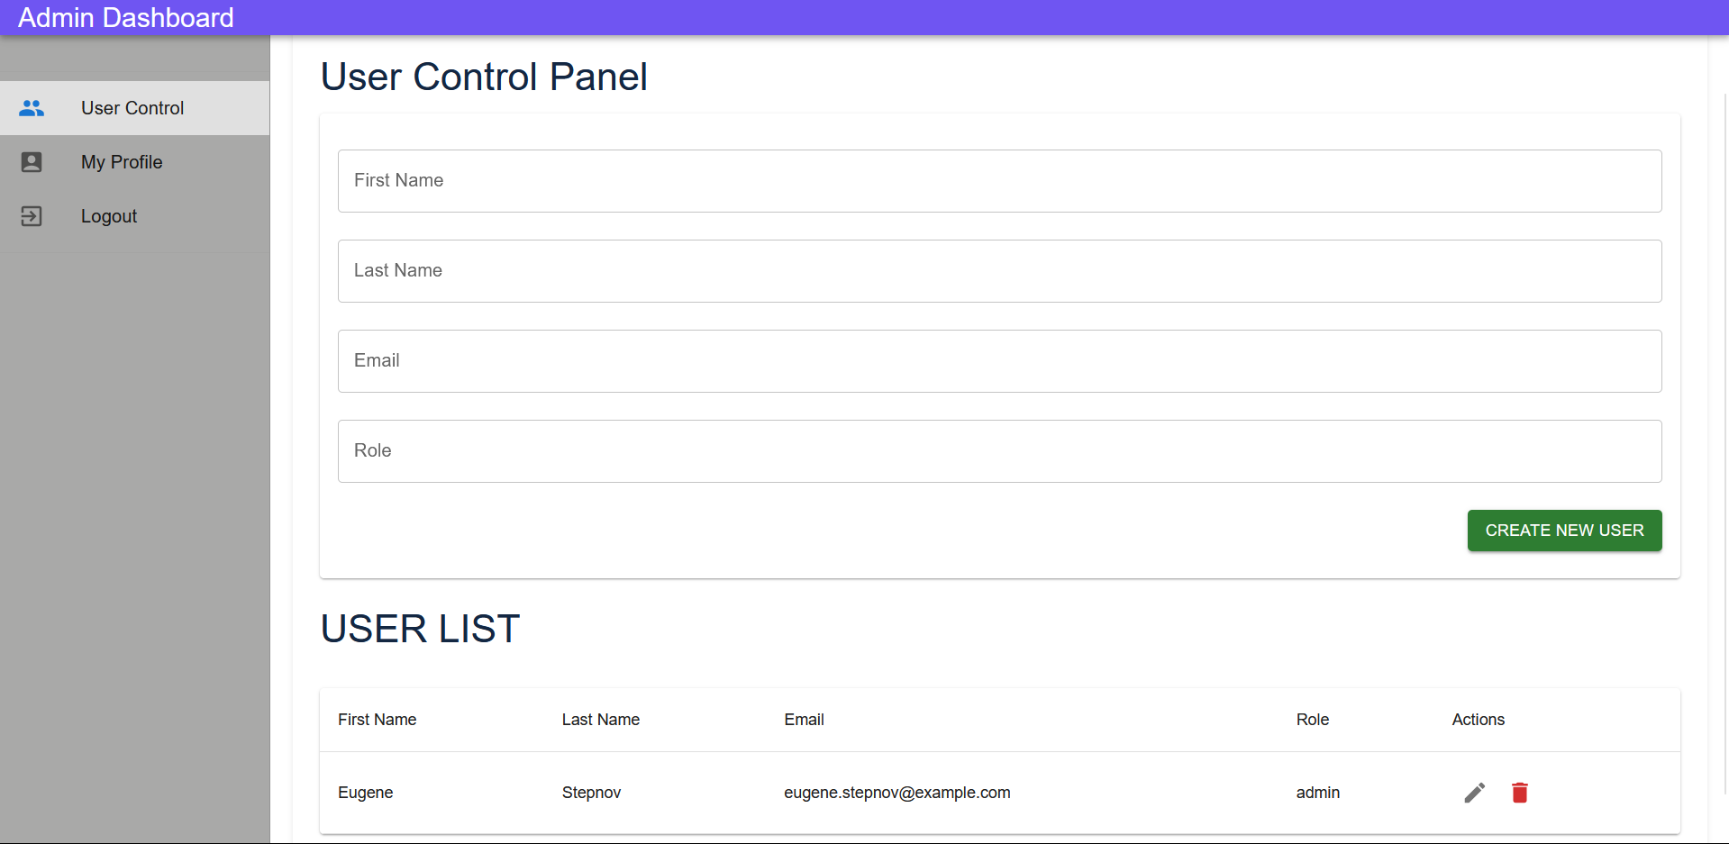  
Admin Dashboard Page**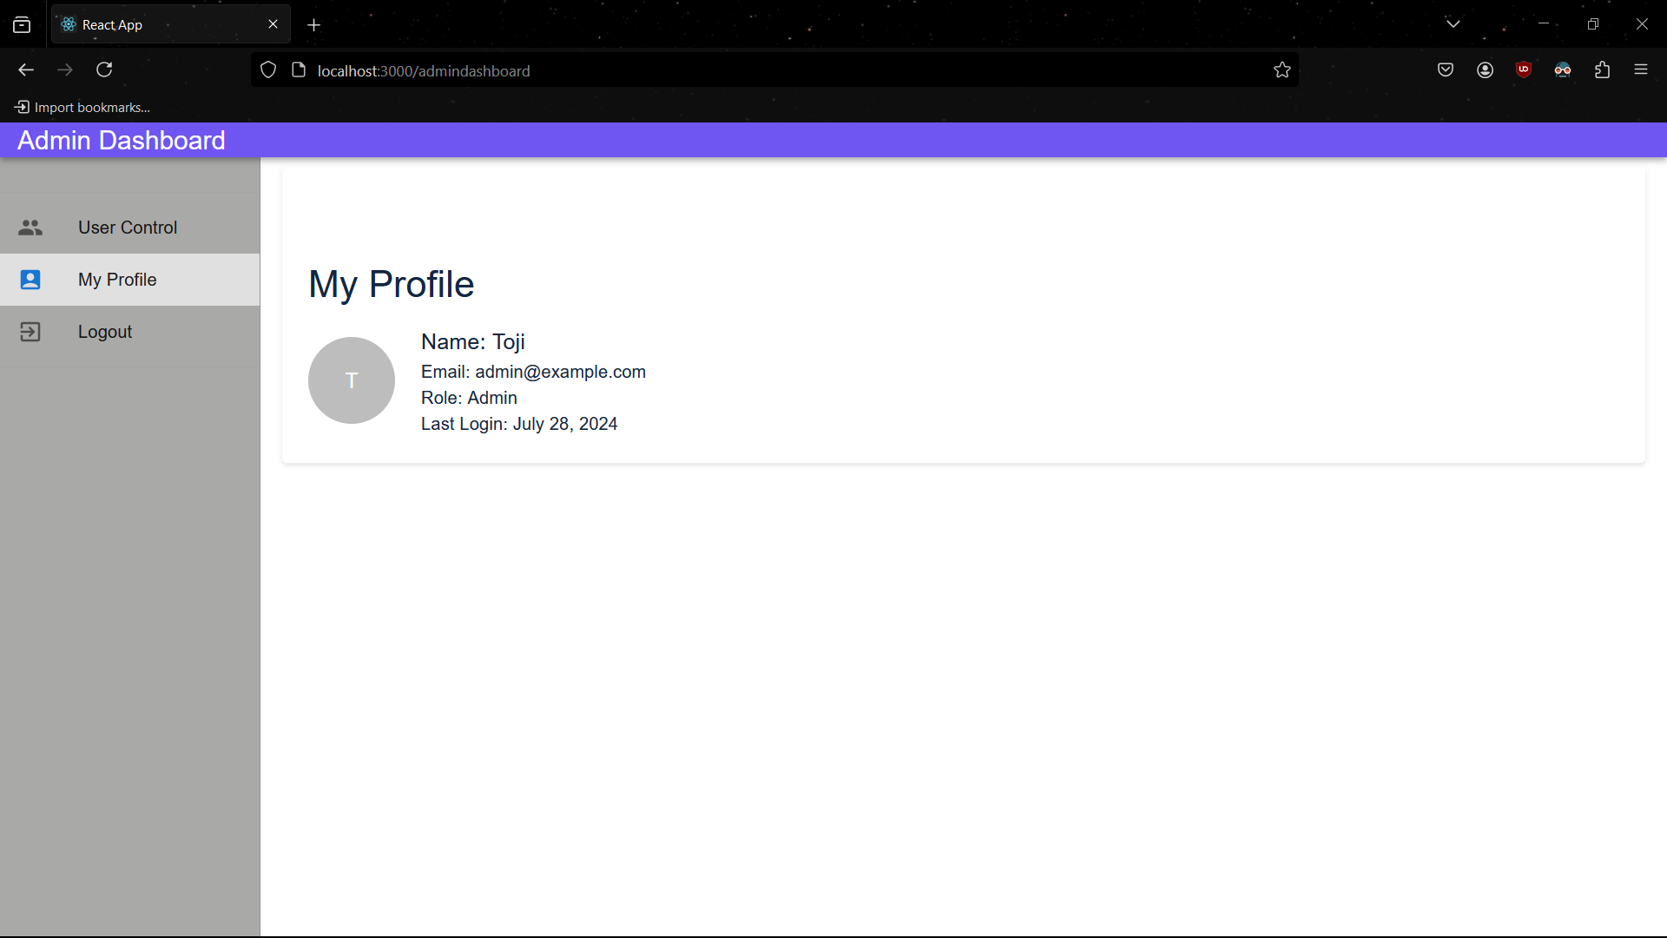

**Admin Dashboard Page**

**ADMIN CHART:**

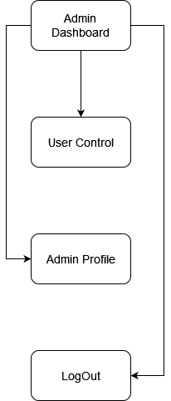

**ADMIN MODULES:**

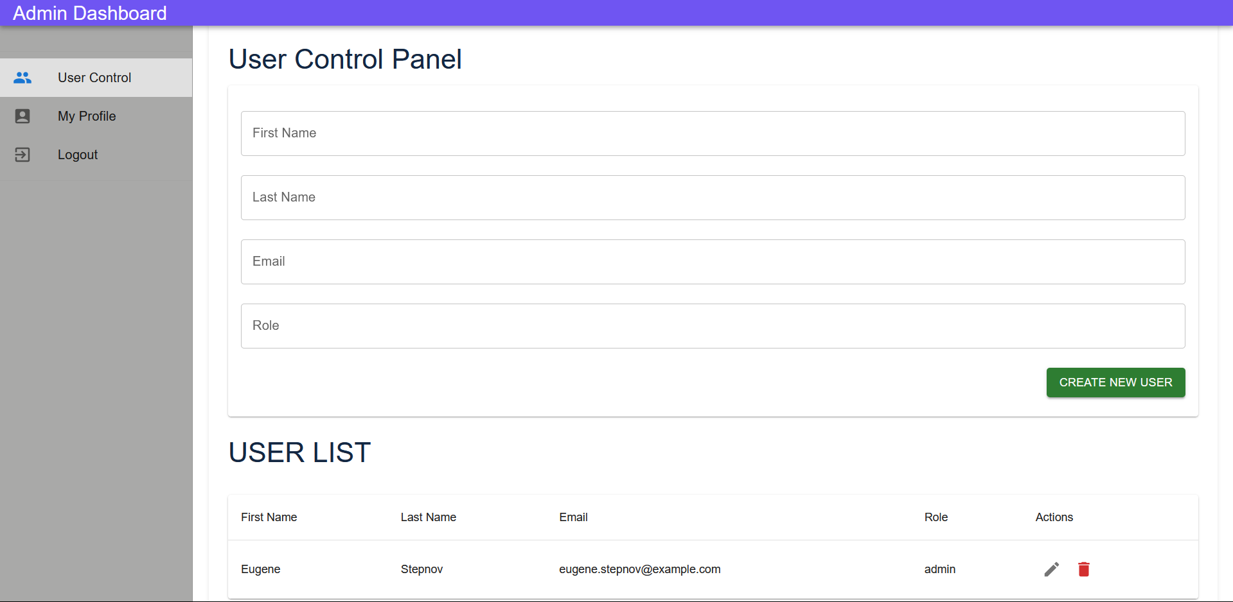

**Admin Dashboard Page**

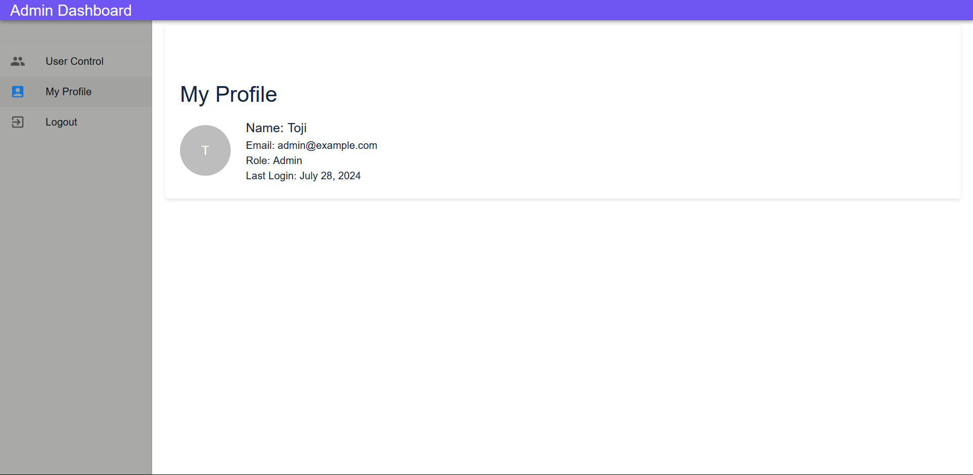

**Admin Profile Page**

**CONCLUSION:**

The **Gym Trainer and Progress Tracker Application** represents a significant step forward in fitness management and personal training solutions. By integrating comprehensive workout programs, detailed progress tracking, and user-friendly interfaces, the application empowers users to take control of their fitness journeys. The project showcases a thoughtful blend of technology and user-centric design, making it accessible and beneficial to a wide range of users, from beginners to advanced athletes.

Through its robust feature set, including an admin dashboard, secure login, and personalized user profiles, the application ensures a secure and customizable experience. The use of modern web technologies like React.js and MUI, along with a consistent and appealing design, enhances usability and engagement.

Overall, this project not only demonstrates technical proficiency but also a deep understanding of the needs and challenges faced by fitness enthusiasts. It stands as a valuable tool for anyone looking to improve their physical health and track their progress effectively. The **Gym Trainer and Progress Tracker Application** sets the foundation for future developments and enhancements, aiming to continuously support and motivate users in achieving their fitness goals.